**Monitor Azure Environment**

🡪Login to the BlueCrest Azure Portal.

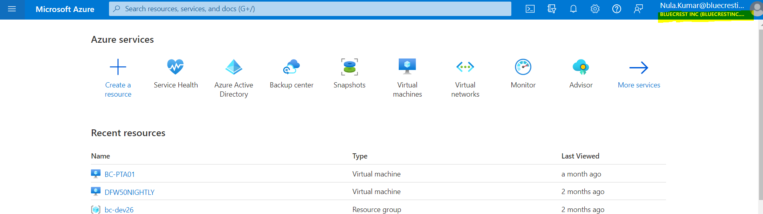

🡪Search for service health

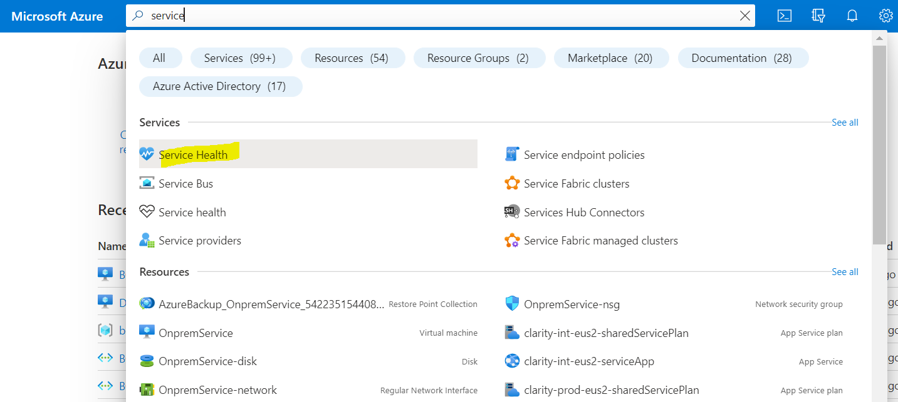

🡪Open service health and check for any health issues and planned maintenance.

If you found any issues or maintenance send the mail to our group [dl-cloud-blc@atos.net](mailto:dl-cloud-blc@atos.net) .And no issues we can make Monitoring environment as completed.

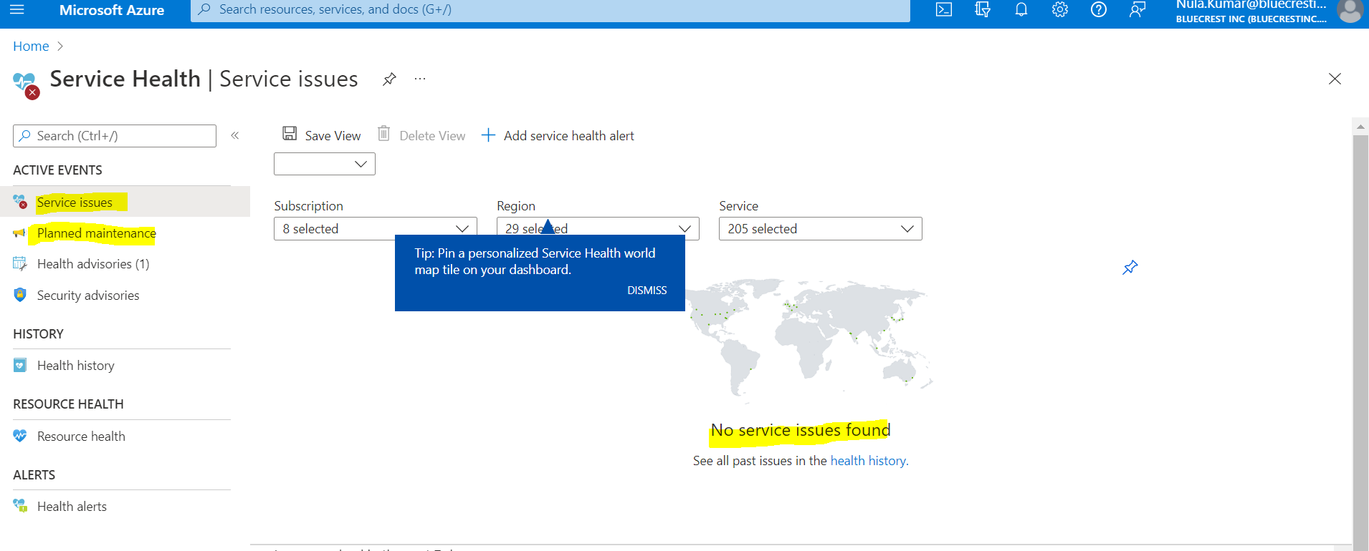

In the global level also we must to check the service health

🡪Open the URL “<https://status.azure.com/en-us/status>” and check in each region the health of azure resources.

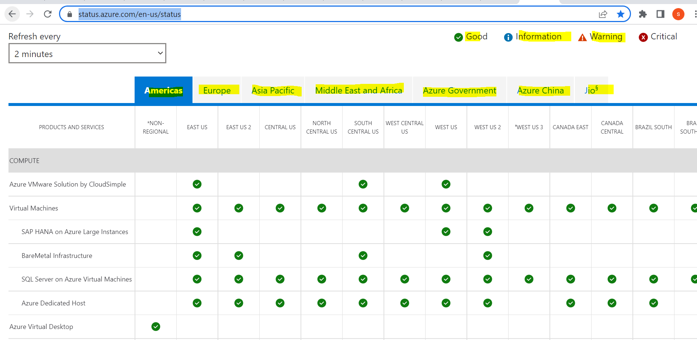

🡪 If you found any health issues of azure services send the mail to our group [dl-cloud-blc@atos.net](mailto:dl-cloud-blc@atos.net) .If no issues we can make Monitoring environment as completed.

In above 2 checks no issues then we can consider Monitoring environment as completed.